Chapter 4 Review Quiz

Instructions:
Do not submit this document. You will be answering these questions on our course Mastering Geology page. Use this document to mark your answers for quick reference.

1) ________ is the name given to molten rock when it reaches Earth's surface.
A) Magma
B) Lava
C) Igneous
D) Melt

2) What are volatiles?
A) the liquid portion of magma
B) silicate crystals in magma
C) the gaseous components of magma
D) ash particles

3) Which of the following is a name for igneous rocks that crystalize beneath Earth's surface?
A) intrusive igneous rock
B) extrusive igneous rock
C) plutonic igneous rock
D) volcanic rock
E) Intrusive and plutonic are both names for igneous rocks that crystallize beneath Earth's surface.

4) ________ is thought to be common in the Earth's mantle but rare in the crust.
A) Pumice
B) Granite
C) Pegmatite
D) Peridotite

5) The sizes, shapes, and arrangements of mineral grains in an igneous rock are known as ________.
A) silica content
B) texture
C) mineral content
D) Bowen's reaction series

6) Extrusive igneous rocks are typically finer grained than intrusive igneous rocks. Why?
A) Intrusive magma is cooler because it is well insulated by the surrounding rock.
B) Intrusive magma flows onto the Earth's surface and cools very slowly, allowing many small mineral grains to grow.
C) The extrusive magma cools quickly so the mineral grains do not have time to grow.
D) The extrusive magma, because it is deep below the surface, cools very slowly producing very small mineral grains.

7) ________ is the dominant lava erupted from volcanoes on Hawaii and Iceland.
A) Rhyolite
B) Andesite
C) Peridotite
D) Basalt

8) All of the following are factors that affect the generation of magma EXCEPT for ________.
A) heat
B) pressure
C) crystal size
D) volatiles

9) Which of the following minerals crystallize early in Bowen's reaction series?
A) biotite
B) quartz
C) olivine
D) muscovite

10) The last minerals to crystallize on Bowen's Reaction Series result in igneous rocks with a(n) ________ composition.
A) felsic
B) intermediate
C) mafic
D) ultramafic

11) Bowen's reaction series predicts the ________ of the different mineral grains that grow from crystallizing magmas.
A) size and color
B) order of crystallization
C) color and shape
D) texture and size

12) Partial melting results in a magma that is nearer the ________ end of the compositional spectrum than the parent rock from which it was derived.
A) felsic
B) ultramafic
C) mafic
D) basaltic

13) Fill in the missing composition names on the chart below.

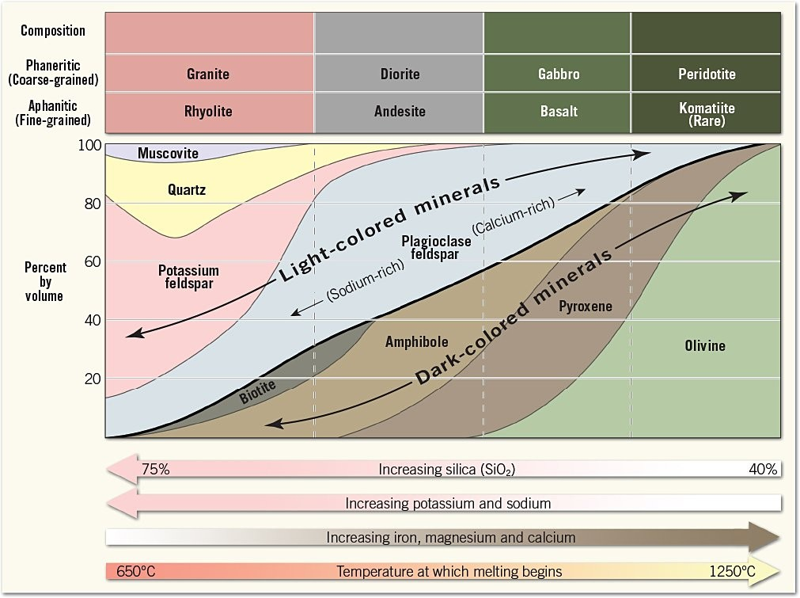
Figure 1: SmartFigure 4.5 of your textbook: Mineral makeup of common igneous rocks.

14) Fill in the missing texture names on the chart below.

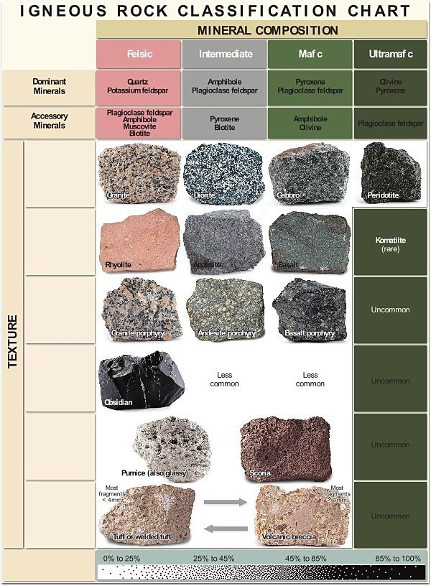
Figure 2: SmartFigure 4.12 of your textbook: Classification of igneous rocks.
15) What magma-generating process is exhibited by the diagram below? When does this process take place?

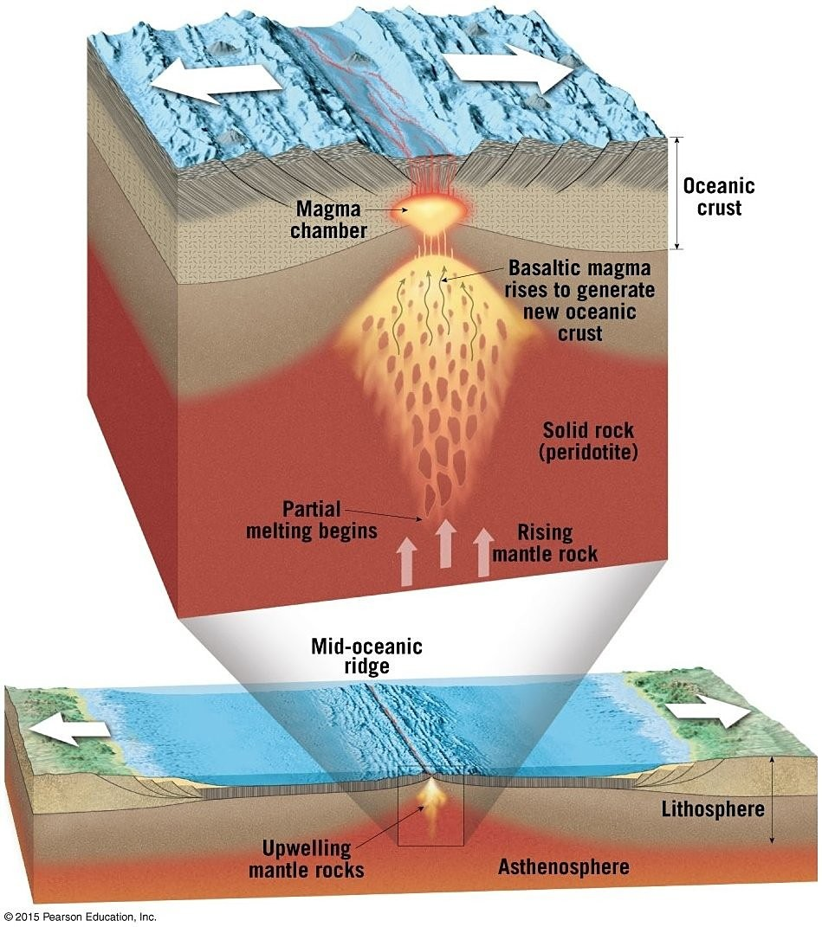
Figure 3: Figure 4.18 of your textbook

